What You Absolutely Need to Know To Pass

the NYS Living Environment Regents Exam June 21

Index of Living Environment Units

Unit 1: Science and the Living Environment (pg 2-4)
- Scientific method
- Controlled experiments
- Graphing
- Characteristics of good experiment

Unit 2: Characteristics of Living Things (pg 5-10)
- Chemistry (carbohydrates, lipids, proteins, enzymes, acids and bases)
- Homeostasis, metabolism, and life processes (including photosynthesis and respiration)
- Cells

Unit 3: Homeostasis and the Human Body (pg 11-15)
- Organization
- Human body systems
- Diseases and disorders

Unit 4: Reproduction (pg 16-17)
- Mitosis and meiosis
- Asexual and sexual reproduction
- Human reproduction and development

Unit 5: Genetics (pg 18-20)
- Genetic code and protein synthesis
- Genetic technology

Unit 6: Evolution (pg 21-23)
- Natural selection
- Speciation
- Gradualism vs Punctuated Equilibrium
- Evidence for evolution
- Classification

Unit 7: Ecology (pg 24-29)
- Interactions between organisms
- Food chains and food webs
- Biodiversity
- Human impact on the environment

Appendix: State Labs (pg 30-36)
- Making Connections (Clothespin Lab)
- Relationships and Biodiversity (Botana curus lab)
- Beaks of Finches
- Diffusion Through a Membrane

UNIT ONE: Science and the Living Environment
- Terms:
  - Observation: What is seen or measured.

  - Inference: A conclusion based on observation or evidence.

  - Hypothesis: A prediction based on available evidence. A good hypothesis states both cause and effect.
    - A correct hypothesis can be tested and falsified (proven incorrect) using an experiment.
    - The easiest way to write a correct hypothesis is as an “if-then” statement. (ex: If I give patients this pill, then they will not get sick.)

  - Theory: An explanation of natural events that is supported by strong evidence.
    - Theories tie together many scientific facts, hypotheses and laws.
    - Misconception: “Theories are things that are opinions, or are not proven.” This is an incorrect use of the word “theory” in a scientific context. A scientific theory is not a simple guess or conjecture, and is strongly supported by evidence.

- Controlled Experiment: Compares the results of an experiment between two (or more) groups.
  - Experimental group: Group being tested or receiving treatment.

  - Control group: “Normal” group. Should be identical to experimental group in every way except one: it does not receive the new treatment.

  - Placebo: A sugar pill or other “fake” treatment given to the control group.

  - Independent Variable: Variable that is being tested (ex: new drug, new fertilizer).
    - The “If” part of an “If-then” hypothesis.
    - The independent variable is always plotted on the X axis.

  - Dependent Variable: Variable that is measured at the end of an experiment; the results.
    - The “then” part of an “If-then” hypothesis.
    - The dependent variable is always plotted on the Y axis.

- Graphs and Data Tables
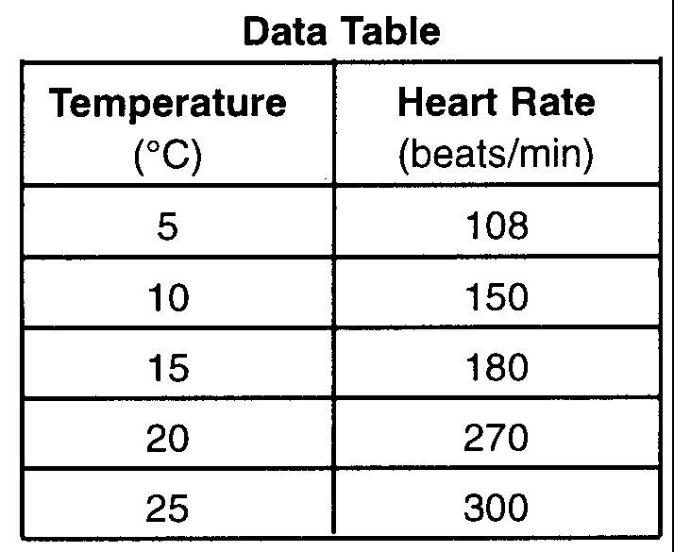
  - Data tables are used to organize data which will be plotted in a graph.
    - First column in the table is for the independent variable.
    - Second column is another for the dependent variable.
    - Each column should be titled, and include units of measurement.
    - Data in the table must be arranged in ascending or descending
order.

  - Both the x and y axis of the graph must be labeled or titled. These labels are typically the same ones used in the data table. Once again units of measurement must be written with the title.

  - The independent variable is always plotted on the x-axis.

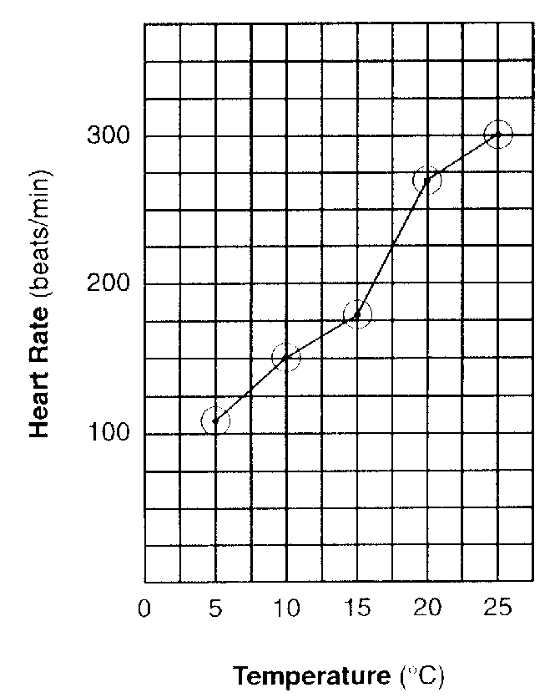
  - The dependent variable is always plotted on the y-axis.

  - The x and y axis must be numbered.
    - These numbers must increase by a uniform increment (that is you must count by 1’s, 2’s, 5’s, 10’s, etc).
    - Your numerical scales should take up most of the axes. Squeezing it all into the bottom corner makes the graph impossible to read and no credit will be given.
    - The numbers must line up with the grid lines of the graph, not with spaces between them.
    - You do not need to start numbering your axis with 0.

  - To date, all graphs drawn on the LE Regents have been line graphs. Any student who draws a bar graph instead of a line graph will be denied credit for this part of the test.

  - All points plotted on your graph must be surrounded by a circle (or sometimes a square or triangle, depending on the directions).
- Characteristics of a good experiment:
  - Can be repeated the same way and get the same results.

  - Have large sample size/many test subjects.

  - Are performed for longer periods of time.

  - Test only one independent variable. All other characteristics of the tested groups should be the same.

  - Are peer reviewed – examined by several scientists to determine its accuracy.

  - Must test the hypothesis and show whether it is wrong or right.

  - Is objective – the experiment and conclusion are fair and unbiased. Fact and opinion are not mixed.

  - The experiment follows established ethical and legal standards.
UNIT TWO: Characteristics of Living Things
- Chemistry
  - The most common elements in living things are (in order) Carbon, Hydrogen, Oxygen and Nitrogen (CHON).

  - Organic Compounds
    - Have Carbon AND Hydrogen (C₆H₁₂O₆ is organic, H₂O is not).
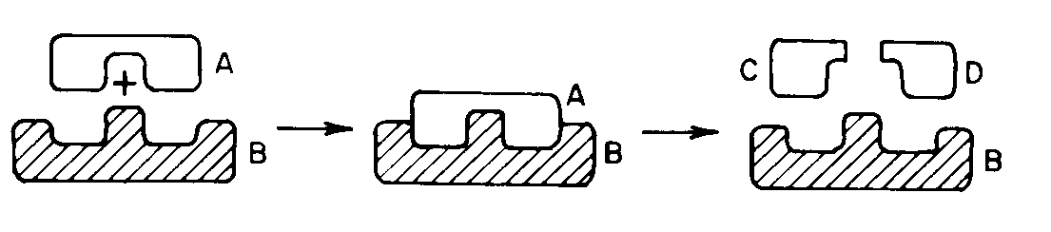
    - Organic molecules are larger than inorganic molecules.

  - Carbohydrates are sugars and starches.
    - All carbohydrates are made from simple sugars (like glucose) and they supply energy.
    - Enzymes may break down starches and complex sugars into simple sugars.
A starch (A) is broken down by an enzyme (B) into two simple sugars (C, D). This is also a good example of the lock and key model.

  - Lipids store energy and include fats, oils and waxes.

  - Proteins are made from amino acids.
    - Proteins make most of the chemicals used to build and run an organism’s body, so as far as your body is concerned, proteins are by far the most important of these three organic molecules.

    - It is the SHAPE of proteins and how they fit together with other molecules that determines what proteins can do.

    - Four specific jobs of proteins:
      - enzymes (see next page for more on enzymes)
      - receptor molecules on the cell membrane. These are used to receive chemical messages (like hormones).
      - antibodies (proteins which fight infection)
      - hormones (chemical messengers)

  - Enzymes are catalysts made from protein.
    - Catalysts affect the rates (speed) of chemical reactions.
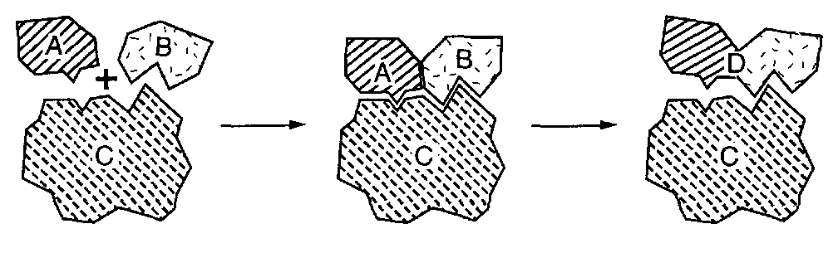
    - Lock and key model – one type of enzyme fits one and only one type of molecule. Change its shape and the enzyme will no longer work (this is true for almost all proteins).
    - Very high temperatures cause proteins and enzymes to lose their shape so that they no longer work properly. This is why high fevers are dangerous.

  - pH: The pH scale measure the strengths of acids and bases.
    - A low pH (0-6) is an acid,
Another example of the lock and key model. In this case, the enzyme (C) is controlling a synthesis reaction.
    - A high pH (8-14) is a base,
    - A pH of 7 is neutral (water).

All living things must maintain homeostasis.
  - Homeostasis is a balanced state in an organism.
  - Dynamic equilibrium means that the body stays balanced by taking action whenever the balance is disturbed (like sweating when the body is too hot).
  - To maintain homeostasis, organisms carry out the same basic life functions: transport, nutrition, excretion, respiration, growth, synthesis, regulation and synthesis. Know these terms!
  - Metabolism is the term used to describe all of these life processes.
  - Failure to maintain homeostasis will result in disease or death.

- Transport:
  - Diffusion: movement of molecules from high concentrations to low concentrations. Requires no energy (passive transport).

  - Active Transport requires the use of energy, usually moving molecules from a low concentration to a high concentration (against the flow of diffusion).

  - Osmosis is the diffusion of water into or out of the cell. If water diffuses into the cell, the cell swells (get larger) and may burst. If it loses water (being put in salt water for example) it will shrivel up.
- Nutrition:
  - Autotrophs make their own food, while heterotrophs eat other organisms.

  - Photosynthesis is carried out by plants, alga and blue-green bacteria (autotrophs). It takes the radiant energy of the sun and puts it in the bonds of sugar molecules. Photosynthesis occurs mostly in the chloroplast of plant cells.

    - Plants have stomates (holes) in their leaves that let them exchange the gasses used in photosynthesis. Guard cells open and close the stomates to keep the plant from dehydrating.

    - Xylem and phloem carry food and water through a plant.

    - Common mistakes:
      - “Photosynthesis gives us energy.” Photosynthesis only stores energy in food (glucose). We need respiration to get the energy out of the food.

      - “Guard cells protect plants from diseases.” Guard cells only protect plants from water loss.

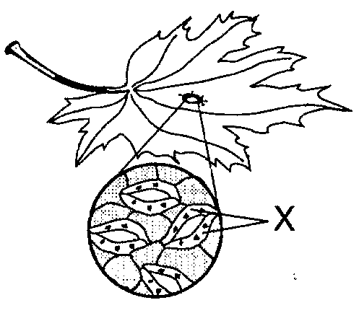
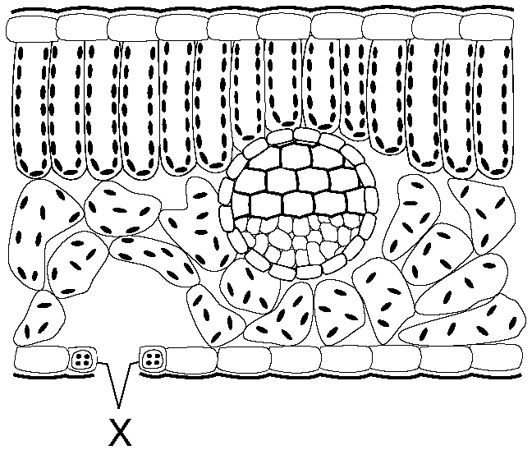

Two different views of the stomates and their guard cells (X).

- Respiration: Process that takes energy from sugar molecules and places it in molecules of ATP. ATP is the energy source of all living things.

  - Aerobic respiration requires oxygen, and yields more ATP (energy) for a molecule of sugar than anaerobic (no oxygen) respiration.

  - When humans are forced to get energy from anaerobic respiration, we produce lactic acid that damages muscles (“the burn” you feel during exercise).

  - Photosynthesis and Aerobic Respiration are opposite reactions! They are also important in cycling oxygen, carbon, hydrogen and water through the environment.
  - Common mistakes:
    - “Plants use photosynthesis, not respiration.” All organisms, including plants, use respiration to get their energy.

    - “Respiration is breathing.” Breathing is not respiration. Breathing exchanges the gases needed for respiration. The simple process of inhaling and exhaling does not give you ATP.

    - “Oxygen is used to breathe.” This is backwards. Breathing is used to get oxygen. Oxygen is then used to obtain energy from chemical respiration. Without oxygen, you have no ATP, and no energy.

    - “All living things need oxygen/need to breathe.” Anaerobic organisms do not need oxygen, and do not have to breathe.

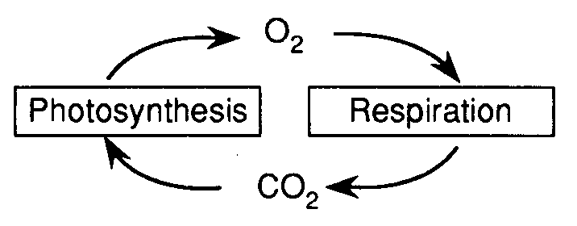

- Regulation: coordination and control of other life functions.
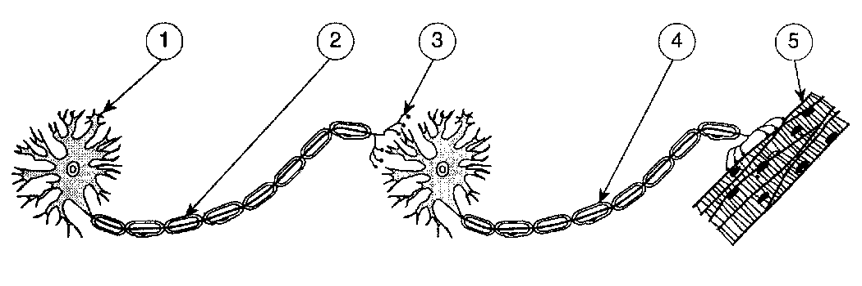
  - A stimulus is a change in the environment that you respond to.

  - A neuron is a nerve cell.

  - An impulse is the electrical signal carried by the nerves. Neurotransmitters are chemicals that help carry the impulse.
Two neurons carry an impulse to a muscle cell.

  - A hormone is a chemical signal secreted by different glands in the body. Examples of hormones include insulin, adrenaline, testosterone and estrogen

  - Receptor molecules are proteins on the surface of the cell membrane that receive signals from the nervous and endocrine system. These are needed for your cells to communicate and work together.
    - As with all proteins, it is the shape of the receptor molecule that determines its functions (in this case, which signals it receives).

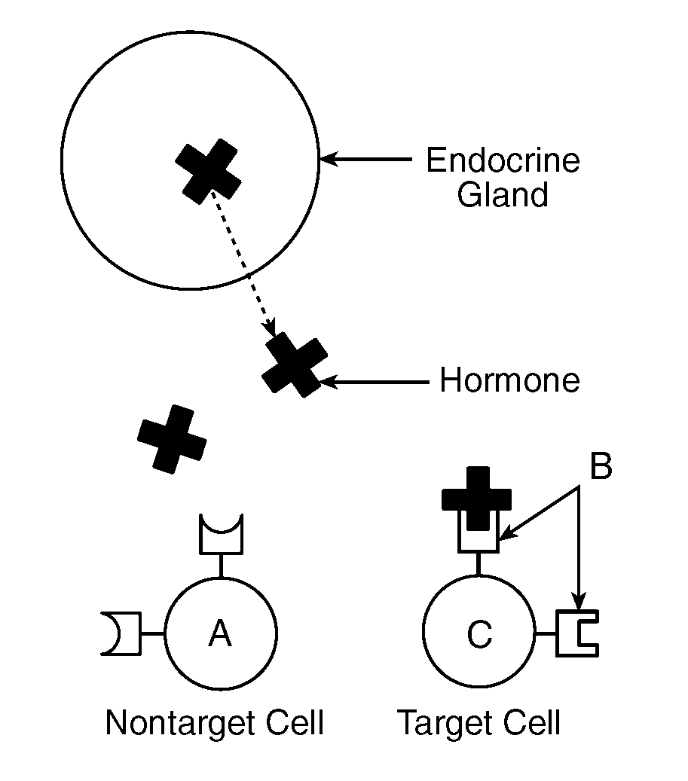

Receptor Molecules in the cell membrane can only accept molecules of the correct shape. This is a good example of the Lock and Key Model.

- Cells- Cells are the basic unit of life. All living things (except viruses) are made of cells.
  - You must know the cell theory:
    - All living things are made of 1 or more cells.
    - Cells carry out all of an organisms life functions.
    - All cells come from other cells.

  - You must know the following organelles and their functions: cell membrane, cell wall, nucleus, cholorplast, cytoplasm, ribosome, vacuole, mitochondria

  - Know the differences between plant and animal cells.
    - Plant cells have cell walls, animal cells do not.
    - Plant cells have chloroplasts, animal cells do not.
    - Animal cells have centrioles, plant cells do not.
    - Animal cells usually have many small vacuoles, plant cells usually have fewer, larger vacuoles.
    - Common mistake: “Animal cells have a cell membrane, plant cells have a cell wall.” ALL cells have a cell membrane, including those with cell walls (plants, fungi, some bacteria and protists). The cell wall is mostly for protection; the cell membrane is needed to control movement into and out of the cell.

  - The cell membrane is made of lipids and proteins. It shows selective permeability – only some molecules can pass through it. (see pg 6 for Transport)
    - Small molecules (like O₂, H₂O, CO₂, and sugars) can pass freely through the cell membrane through diffusion.
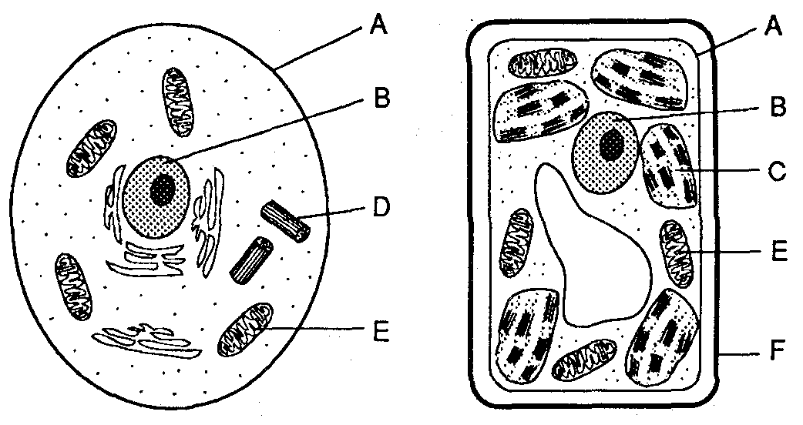
    - Large molecules (like proteins and starches) cannot pass through the cell membrane without the help of transport proteins.
    - If the cell must use energy (ATP) to move a molecule, it is called active transport.
    - The basic types of proteins in the cell membrane are:
      - Receptor proteins
      - Transport proteins
      - Antigens

UNIT THREE: Homeostasis and the Human Body
- Organization:
  - Cells are specialized into tissues.
    - Tissues are groups of cells specialized to do certain jobs. Examples of tissues include muscle tissue and nerve tissue.

    - Specialization or differentiation is the process that changes a stem cell into a specialized tissue.
      - Almost every cell has a complete set of genes, but only those genes needed for the cells particular job are “turned on”.
Example: A red blood cell has all the genetic information needed to make nerves cells, bone cells and skin cells, but all of those “extra” genes are turned off - only the red blood cell genes are turned on.
      - Stem cells are cells that have not yet been specialized.

  - Tissues work together to form organs (heart, lungs, kidney).
  - Organs work together in organ systems (digestive system, nervous system, etc).

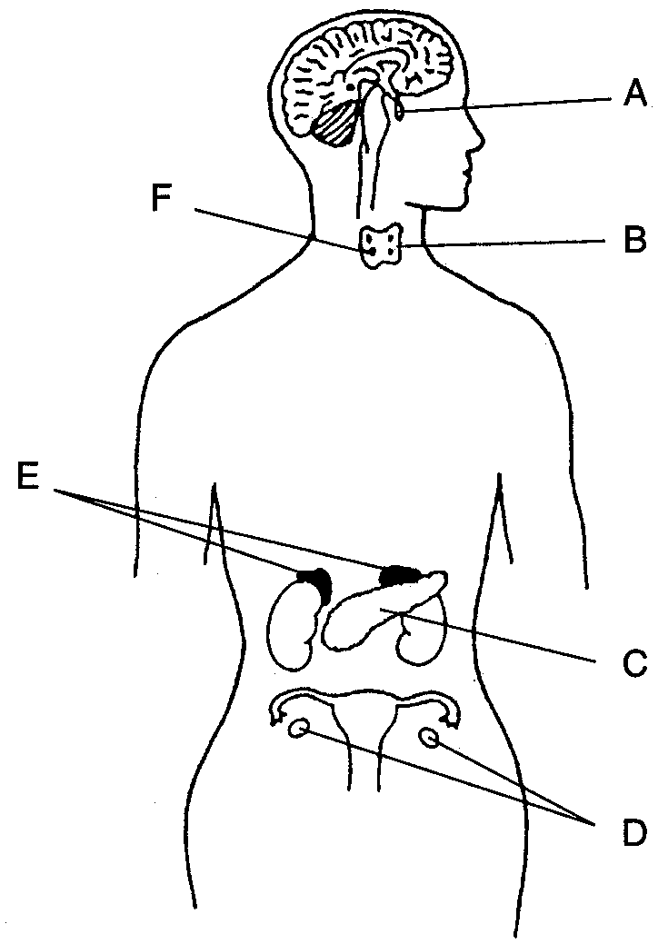
- The Nervous System: (see also Regulation on pg 9)
  - The nervous system regulates your body with electrochemical impulses.
  - The spinal cord controls reflexes and relays impulses between the brain and body.

- Endocrine System: (see also Regulation on pg 9)
  - Uses hormones to regulate the body along.
  - Slower than the nervous system but with longer lasting effects.
  - The pancreas makes insulin and glucagon which control blood sugar.
    - Common mistake: “Insulin lowers blood pressure.” Insulin (and glucagon) directly control blood sugar (or glucose) levels, not blood pressure.
  - Adrenal glands make adrenaline when the body is under stress.
  - Testosterone (male), estrogen and progesterone (female) are the sex hormones. These are made in the gonads (testes for males, ovaries for females).
  - Hormone levels are controlled by feedback mechanisms.
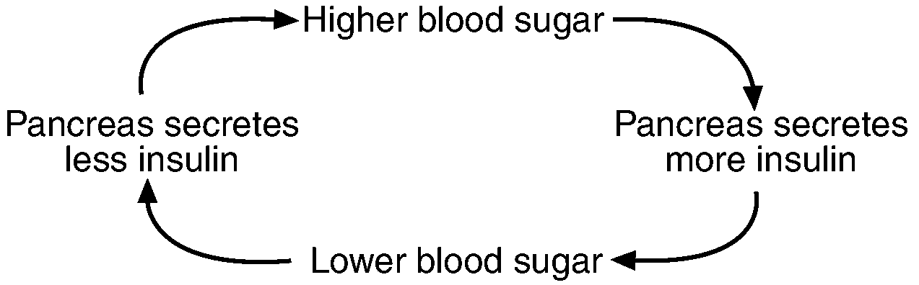
The brain (nervous system) and some endocrine glands

A feedback mechanism
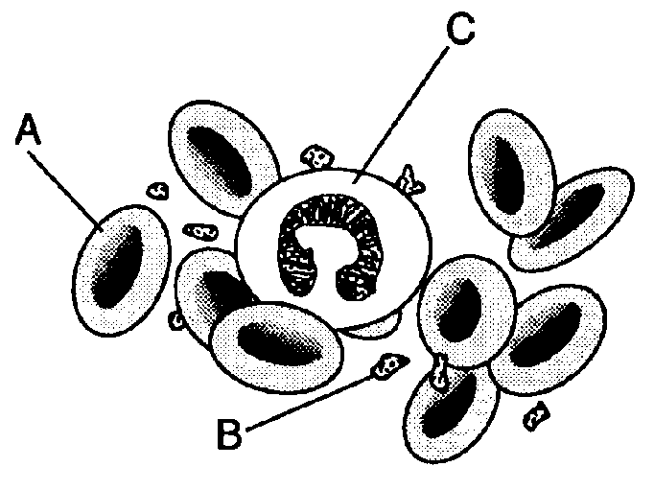
- Transport/Circulatory System.
  - Moves material (water, nutrients, hormones, wastes) through the body to the cells that need them.
  - The Heart is the pump that drives the circulatory system.
  - Red blood cells carry oxygen. White blood cells fight disease.
  - Plasma is the fluid of the blood. It transports everything except oxygen.
  - Platelets clot the blood.
  - Common mistakes:
    - “The heart controls the body.” It is the brain, nerves, and endocrine glands that control the body. The heart is only a pump. It does not control the body, and it is not part of the nervous or endocrine system.
Red blood cells (A), platelets (B) and white blood cells (C)
.

    - “The heart pumps oxygen to the brain.” Technically true, but the heart pumps blood (which carries the oxygen) everywhere in your body.
    - “Oxygen diffuses into and out of the heart.” No materials diffuse in or out of the blood when it is in the heart. This only occurs in capillaries.

- Respiratory System:
  - Breathing provides oxygen needed for chemical respiration (which releases energy from sugar). It also excretes the waste CO₂ which is produced from respiration.
  - The diaphragm is the muscle that allows breathing to occur.
  - You breathe faster when CO₂ builds up in the blood (not when you need oxygen).
  - The alveoli are microscopic sacs where oxygen enters the blood and CO₂ leaves the blood. The alveoli are surrounded by capillaries.
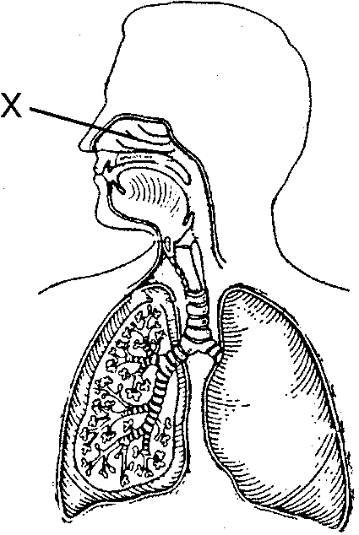

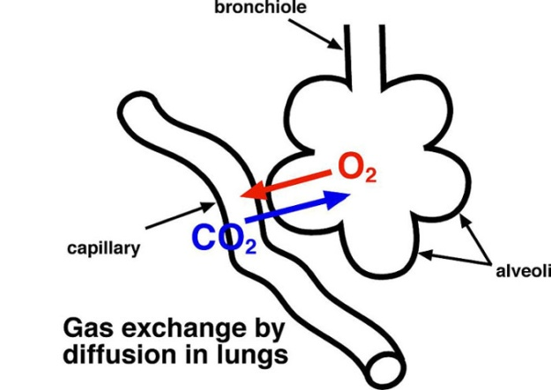

The respiratory system
- Immune System:
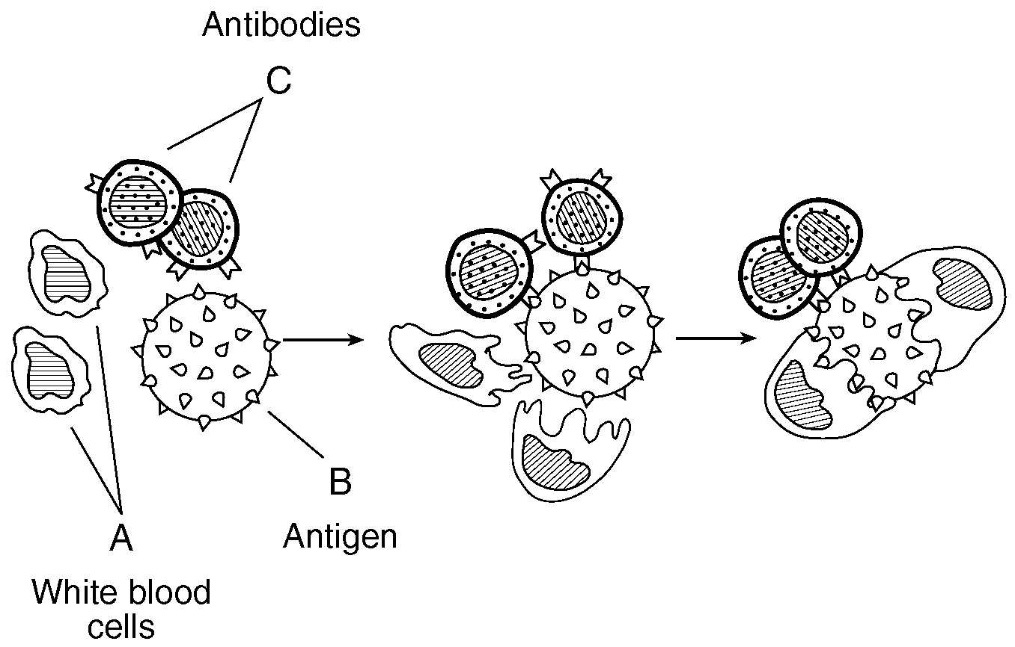
  - The job of the immune system is to protect the body against pathogens.
  - Types of pathogens include viruses, bacteria, and parasites.
  - White Blood Cells are the main components of the immune system.
    - Different w.b.c’s have different roles, including:
      - Identify pathogens
      - Tag” pathogens for destruction by other wbc’s.
      - Destroy pathogen by eating it.
      - Destroy pathogen using chemicals
      - Make antibodies

  - Antigens are protein “tags” on that can be used to identify a cell or virus. Cells and viruses which have antigens different than yours will cause an immune response.
An immune response – white blood cells and antibodies attack a virus.
  - Antibodies are also proteins made by white blood cells to attack antigens. Each antibody attacks a specific antigen as determined by its shape.
    - Be able to explain why your body’s immune system rejects organ transplants.
    - Blood type O is a universal donor; type AB is the universal acceptor.
    - Common mistake:
      - “Antibodies are cells that attack pathogens.” Antibodies are proteins, not cells.

  - A vaccine is an injection of a dead or weakened pathogen. This causes the body to make antibodies against that pathogen. It is effective against both viruses and bacteria.
Kidneys and Urinary Tract - part of the human excretory system.
    - Common mistake: “Vaccines are used to cure diseases.” Vaccines only prevent diseases you do not already have. They are not cures.

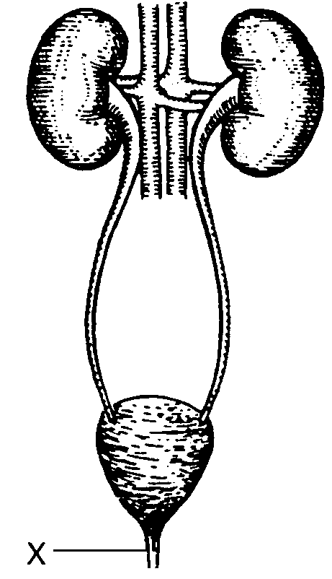
  - Antibiotics are drugs used to stop infections by bacteria. Antibotics will not work against viruses. Unlike vaccines, antibiotics can cure diseases.

- Excretory System:
  - Removes metabolic cellular waste from your body.
    - These wastes include salt, water, urea and CO₂.
  - Lungs excrete CO2 and water and the skin excretes sweat.
  - The kidneys filter waste from blood and reabsorb nutrients.
  - The liver filters toxins and dead red blood cells from the blood.

The human digestive system
- Digestive System:
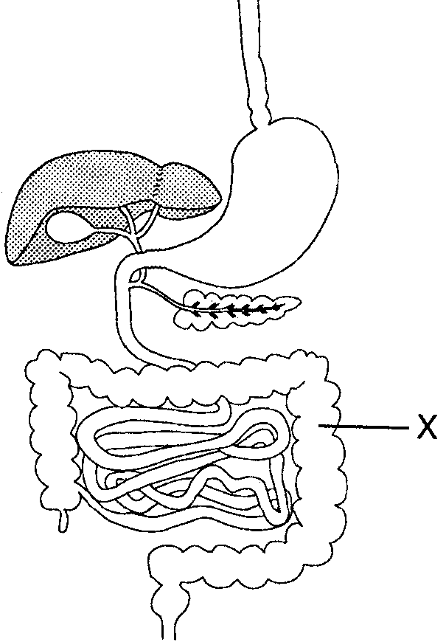
  - Food is broken down so that it is small enough to enter the body tissues/cells.
    - The digestive system is a one way passage through the body that includes the mouth, stomach and intestines.
    - Food is moved through the digestive system by muscular contractions (peristalsis).
    - Food is broken down mechanically and chemically.
    - Undigested food is eliminated as solid waste (feces).
    - Common mistakes:
      - “Feces are excreted from your body.” Feces do not come from your cells, so it is technically not excreted.
      - “The digestive system excretes waste.” The digestive system does remove waste (feces), but again “excrete” is not correct.
      - “The digestive system gives you energy.” The digestive system gives you nutrients, not energy. Energy is gained only by chemical respiration.

- Interaction between Systems:
  - Be able to explain how different systems of the body work together to maintain homeostasis. For example:

    - Nutrients from the digestive system are transported to cells by the circulatory system.

    - Wastes from the respiratory system are removed by the excretory system.

    - The nervous and endocrine systems work together to control the body.

    - The immune system protects the nervous system from disease.

    - The digestive system gives nutrients to the endocrine system.

- Diseases and Disorders:
  - Be familiar with different diseases and disorders, what causes them, and how they may affect the body. Don’t fret about memorizing all of them. Typically the exam asks you to name a disease and how its disrupts homeostasis.
  - The most important diseases and disorders for you to know are:
    - AIDS
      - Caused by HIV virus (a pathogen)
      - Weakens human immune system, leaving body vulnerable to other diseases.
      - Spread through bodily fluids, usually sexual contact, intravenous (IV) drug use (sharing needles), or blood transfusions.
      - Can’t be cured, but spread may be prevented by sexual abstinence, “safe” sex (using condoms), not sharing needles, or testing blood before using it for a transfusion.
    - Cancer
      - Caused when a cell reproduces (divides) at an uncontrolled rate, forming a tumor.
      - Cancer cells do not specialize and take resources from healthy tissue.
      - May be cause by radiation, chemicals (such as asbestos or cigarette smoke), and viruses.
      - Treatments include surgery, radiation therapy, and chemotherapy.
    - Diabetes
      - Affects body’s ability to control blood sugar.
      - Some diabetics may be treated using injections of insulin made by genetically engineered bacteria.
    - Allergies
      - Occur when immune system reacts to a harmless substance (such as pollen) the same way it would a harmful pathogen (such as a cold virus).
      - Asthma is a form of allergy caused by a reaction to dust particles in the air.

UNIT FOUR: Reproduction
- Asexual reproduction:
Mitosis vs Meiosis.
Notice the number of chromosomes stays the same in mitosis, and is halved in meiosis.

  - Advantages: faster, easier
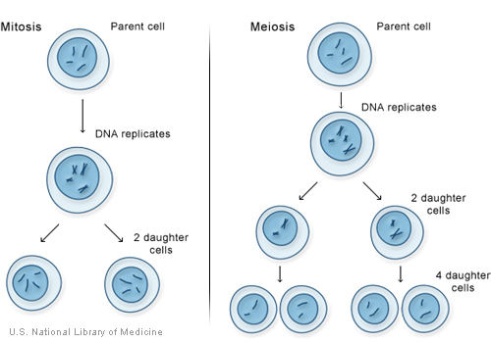
  - Disadvantage: no variety. Offspring are the same as parent.

- Sexual reproduction:
  - Advantage: variety due to recombination of genes.
  - Disadvantage: more time, effort and risk.

- Mitosis
  - Used in all forms of asexual reproduction.
  - The number and types of chromosomes in the daughter cells are the same as in the parent cell.
  - Large organisms use mitosis for growth and healing. Simple organisms use it to reproduce.
  - One division of a cell → two identical, diploid (2n) cells.

- Meiosis
  - Makes gametes used in sexual reproduction.
  - One cell divides twice → four DIFFERENT haploid (1n) cells.
    - Separates pairs of homologous chromosomes so that offspring get one chromosome of each pair from a different parent.
    - Each daughter cell (gamete) gets only one half of the chromosomes of the “parent” cell.

- Male Reproductive System
  - Testes produce and store sperm.
  - Testosterone is the male sex hormone, and is made in the testes.

- Female Reproductive System
  - Ovaries produce eggs.
  - The menstrual cycle lasts 28 days (on average)
    - Ovulation – release of an egg (typically 1 per cycle)
    - Menstruation – shedding of the uterine wall
    - If pregnancy occurs, the menstrual cycle will temporarily stop.
  - The fallopian tube carries the egg to the uterus.
  - The uterus is the womb where the baby will develop.
  - The vagina is the birth canal where the baby will leave the body.

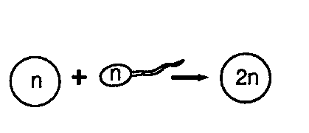
- Fertilization occurs in the fallopian tube (oviduct).
  - A fertilized egg is called a zygote.
  - Fertilization restores the complete set of chromosomes, so the zygote is diploid (1n from the egg + 1n from the sperm = 2n).
Fertilization retores the correct number of chromosomes.

- A zygote develops into an embryo and then into a fetus.

- The placenta transfers nutrients and oxygen from the mother’s blood into the blood of the fetus through the process of diffusion. The blood of the mother and fetus do not mix.
  - The fetus is attached to the placenta by the umbilical cord.
  - Waste produced by the fetus is also removed by the placenta.
    - Waste (CO₂, urea, salts) diffuse from placenta into mother’s blood.
    - Since the fetus does not eat solid food, it does not have to eliminate feces.

- The embryo and fetus develop in the uterus.
  - Cells divide without becoming larger (cleavage).

  - After a few days, cells begin to differentiate – that is they start to form different types of cells (nerve, skin, bone, etc).

  - The embryo is very vulnerable to alcohol, drugs, etc because the important organs and systems are just starting to develop.

  - Common mistake: “The fetus develops in the placenta (or vagina, stomach, etc).” The fetus develops in the uterus (or womb).

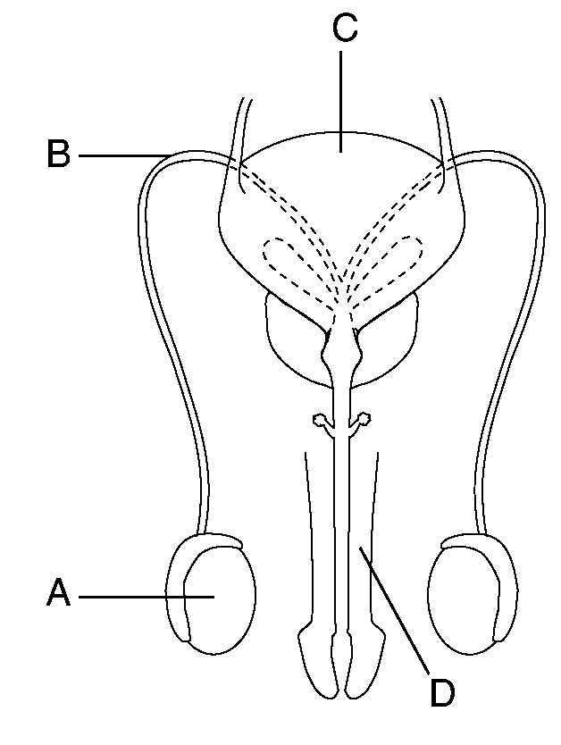
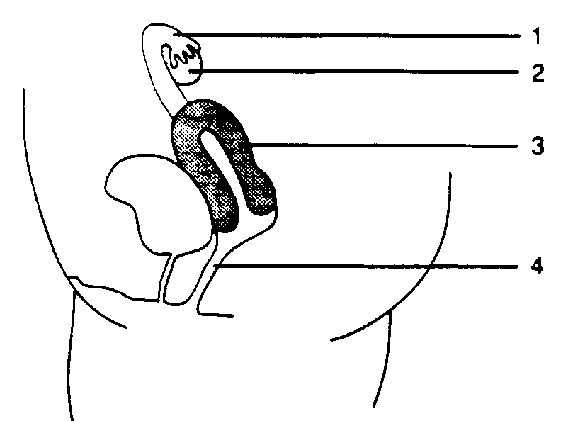
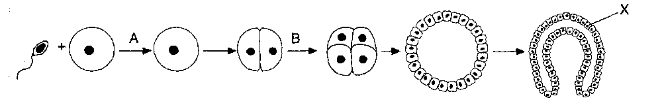
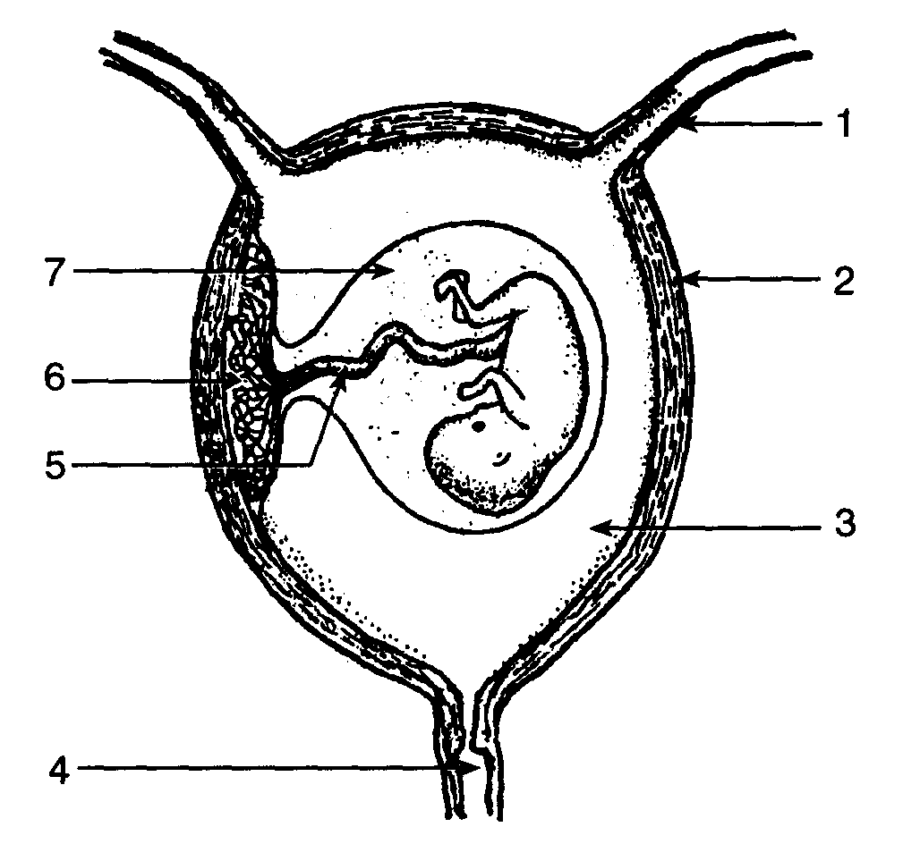
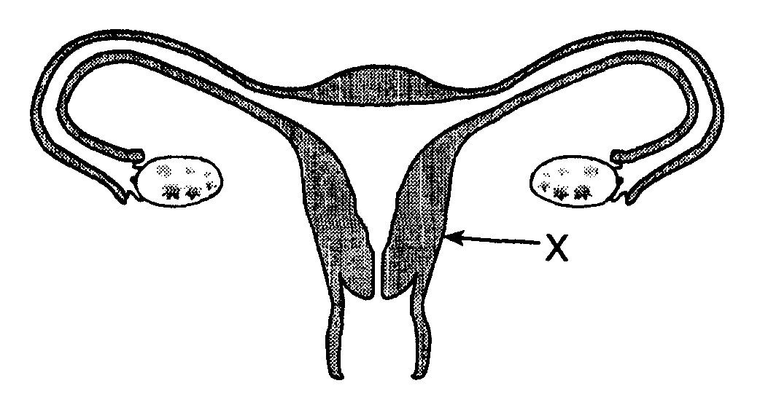
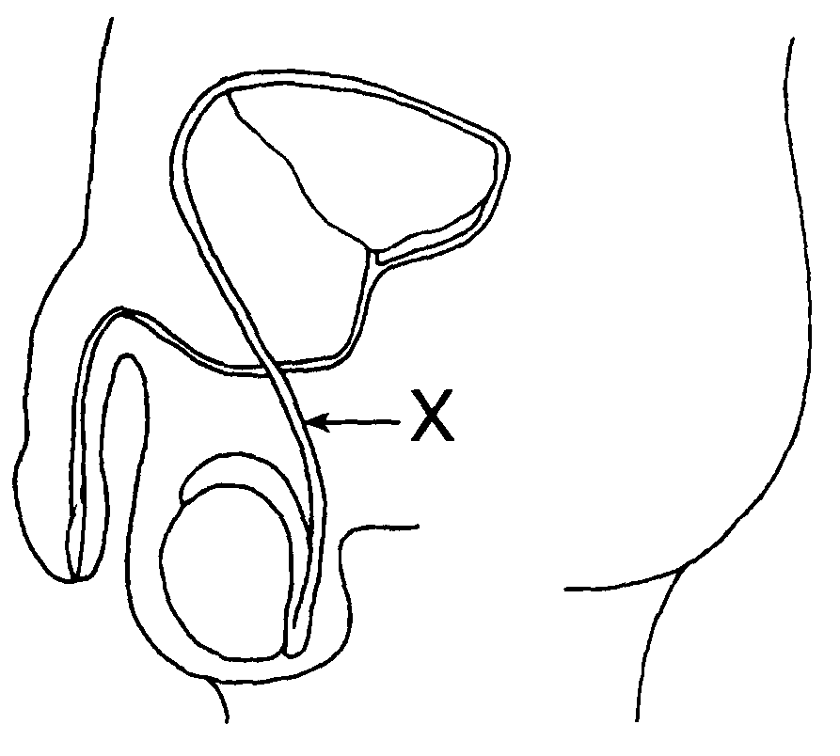
Early development – Fertilization (A) forms a single celled zygote which then begins the process of cleavage (B) which will eventually create a layered ball of cells that will form the embryo.

Front and side views of the male and female reproductive systems
Late Development – The fetus pictured here is nearly ready to be born. Note the umbilical cord, placenta and amniotic sac.

UNIT FIVE: Genetics
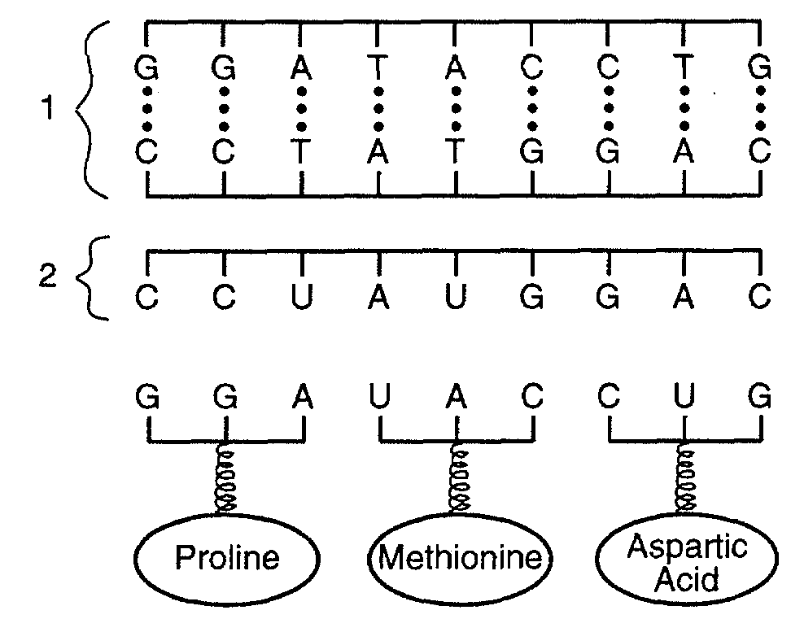
- Humans have 46 chromosomes, or 23 homologous pairs.
  - Common mistake: “Humans have 23 chromosomes (or 46 pairs of chromosomes, or some other incorrect number).” These numbers are often confused. You must memorize them correctly.

- Chromosome pairs carry alleles for the same trait. We all have two alleles for each gene - 1 from each parent, 1 on each member of the homologous pair.

- Sex chromosomes – In humans, females are XX and males are XY.
  - The Y chromosome is much smaller than the X, so males carry only a single gene for some traits. This makes males more likely to have some traits (like color blindness). These are called sex linked traits.

- While genes determine our traits, the environment can affect expression of genes.

- Each chromosome has hundreds or thousands of genes.

- Each gene codes for a particular protein.
  - Common mistake: “Genes/DNA are made from protein.” Genes carry the instructions to make protein. The genes themselves are made from nucleic acids.

- DNA is made of 4 bases: ATCG. A three letter codon represents a specific amino acid. These amino acids are assembles into proteins.

- Base pairs: A-T and C-G (in RNA, A-U and C-G)

- RNA carries the genetic code to ribosomes and the ribosomes synthesize (make) protein.

- Changes to DNA are called mutations. They can only be passed on if they occur in reproductive cells (sperm or egg).
  - Common mutagenic agents include radiation, chemicals, and viruses.
  - Mutations may cause a change in the structure of the protein coded for by a gene. This will have an effect on the way the protein works (if it still works at all).

- All cells in the body contain the same genes. Only some of these genes are turned on. We do not yet know exactly why this happens.

- You must know examples of genetic technology:
  - Selective breeding produces animals and plants with desired traits (disease resistance, larger fruit, more meat or milk, specific colors).

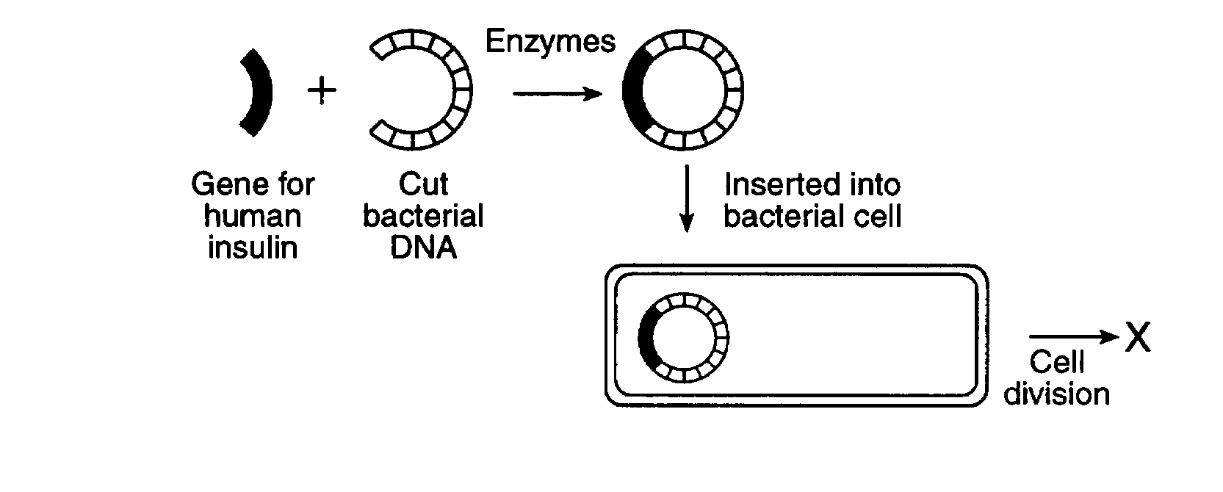
  - Genetic engineering or gene splicing inserts genes of one organism into the genes of another. Enzymes are used to cut and copy the DNA segments. Bacteria are often used because they have no nucleus protecting their DNA and they reproduce very quickly, allowing large amounts of medicine (insulin) to be made. The example of gene splicing you MUST know:
    - The gene to make human insulin was inserted into bacteria. These bacteria can now make insulin that is exactly the same as human insulin. This insulin is used by diabetics. This is safer than the cow and sheep insulin that were used in the past.

  - New technologies (karyotyping, DNA fingerprinting) are making it easier to diagnose and treat genetic disease, though we cannot yet cure them.

- Genetic research has posed many ethical problems (ie right and wrong) that science alone cannot answer.
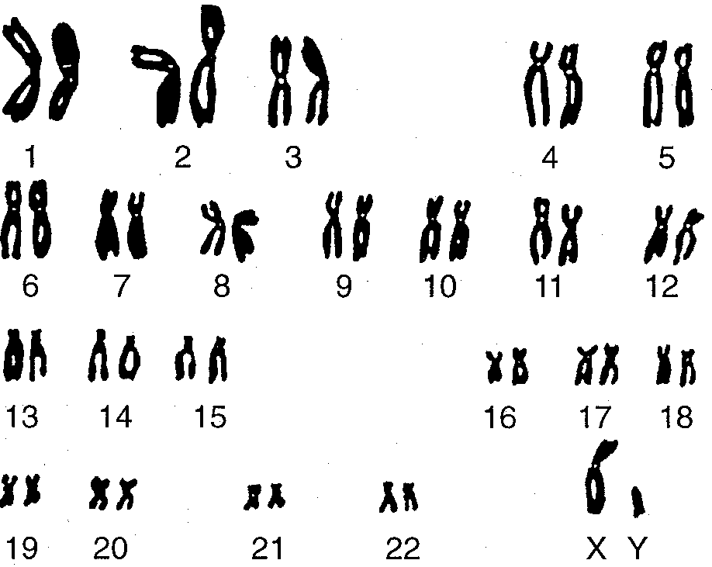
A karyotype shows all 23 pairs of human chromosomes. Note the last pair identifies this as a male.

UNIT SIX: Evolution
- Modern species evolved from earlier, different species and share a common ancestor.

- Charles Darwin proposed that natural selection is the mechanism that causes species to change. The basic steps in natural selection are:
  - Overproduction of offspring. Offspring have variation.
  - Competition for limited resources. Variations affect outcome of competition.
  - Survival and passing on genes OR death and no passing on of genes.
  - Variations that are beneficial are passed on and become more common in a population. Those that are harmful become less common because they are not passed on.

- “Fit” organisms are better adapted to their environment and able to successfully pass on their genes.
  - Unfit organisms usually die and do not pass on their genes, so their traits are eventually removed from the gene pool.
  - Common mistake: “Stronger organisms are more fit than weak ones.” Evolutionary fitness is not physical fitness. Fitness is determined by who is better adapted to survive in a particular environment and who can pass on their genes. Stronger is not always better.

- Evolution is usually driven by a change in the environment. This includes a change in the organisms living in the environment (such as a new species moving into the area).

- Species that cannot adapt to changes in their environment become extinct.
  - Species with little or no variety have a more difficult time adapting to new environments, and are thus more likely to become extinct than those species with greater variety among individuals.
  - Common mistake: “The animal could not adapt and it went extinct.” Individual organisms die; they cannot go extinct. Only species can become extinct.
- To evolve, variations must exist in a species BEFORE the environment changes (pre-adaptation).
  - Common mistake: “Giraffes got long necks because they needed them to eat leaves at the tops of trees.” Species do not evolve traits because they need them. Short necked giraffes were never given long necks – they were out competed by longer necked giraffes. Better answers are “Giraffes evolved long necks because the ones with longer necks were better adapted to get food than short neck giraffes,” or “Giraffes evolved long necks because more short necked giraffes died, and more long neck giraffes lived and reproduced.”

- Variations exist primarily as the result of sexual reproduction and mutation.

- Species with more variation are better able to survive environmental changes than species with little diversity.

- Gradualism is the idea that says evolutionary change occurs slowly. Punctuated equilibrium says evolution happens in “quick” bursts.

- Creation of new species usually requires geographic isolation which eventually results in reproductive isolation.

- Evidence in support of evolution comes from the fields of geology (fossil record and radioactive dating), genetics, biochemistry, anatomy and embryology (among others).

- Classification- Organisms are classified based on their evolutionary relationship.
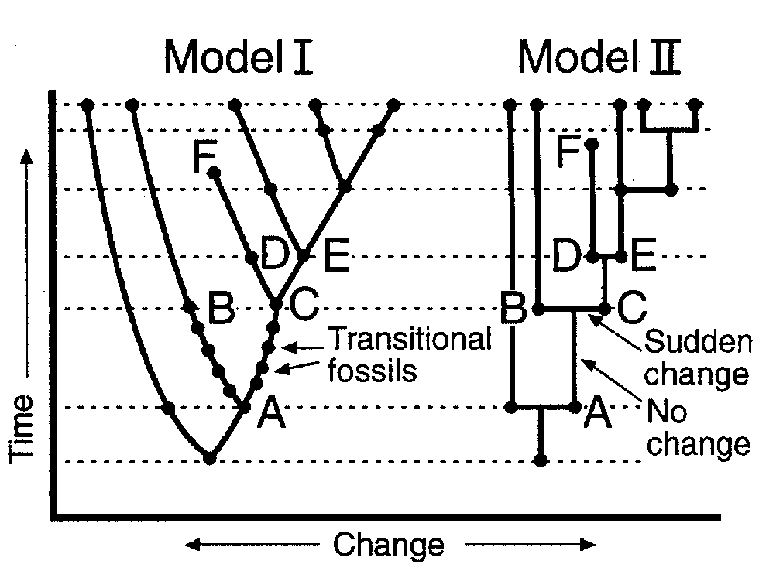
  - Kingdoms are large groups of related organisms (fungi, bacteria, protists, animals, plants).
  - A species is able to successfully reproduce amongst its members.
  - Branching tree diagrams (cladograms) are often used to show evolutionary relationships.

Gradualism (Model I) vs Puntuated Equilibrium (Model II)

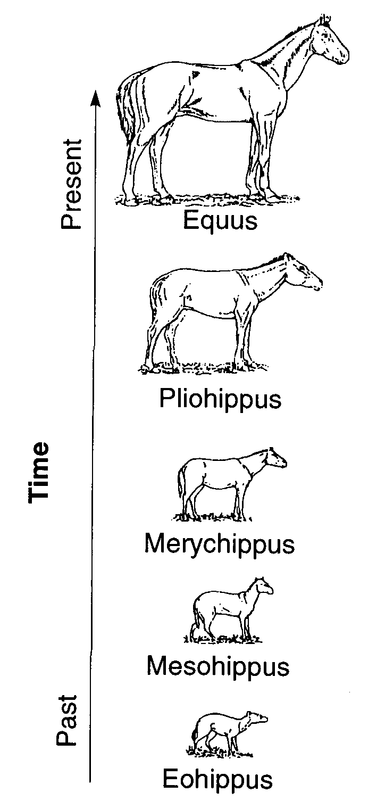
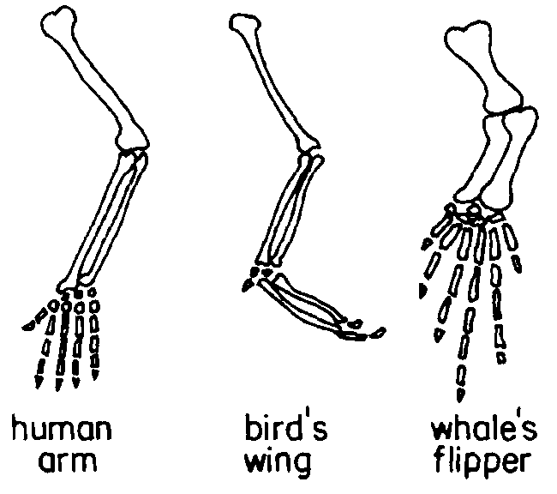
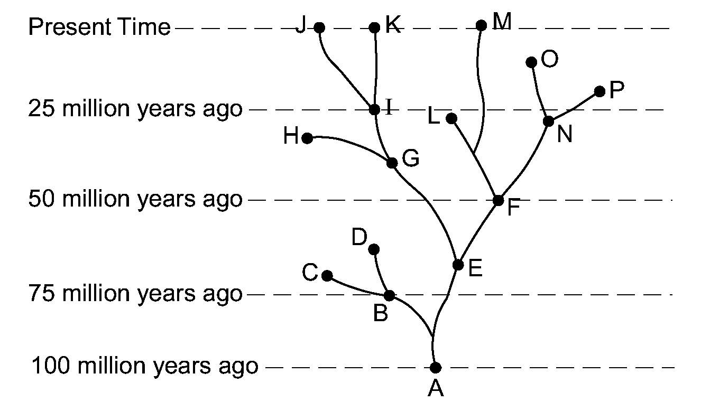
Transitional forms for many species can be found in the fossil record. This diagram shows the evolution of the modern horse from a small, many-toed ancestor.
Evolutionary trees can show the relationship between living and extinct species.
Deeper fossils are typically older than those above them.
Homologous Structures reveal that the same body parts can be modified to perform different functions.

Unit VII. Ecology: the interaction of living things with each other and their environment
  - Habitat: where an organism lives
  - Niche: role (especially feeding) of an organism
    - Two species in an ecosystem trying to fill the same niche will create competition , which usually results in only one species occupying a niche at any one time. Organisms with similar needs will often divide resources to reduce competition (ex: birds eat insects during the day, bats eat them at night).
  - How organisms interact with each other:
    - Competition: Ex: A squirrel and a chipmunk compete for food.
    - Feeding: One organism feeds on another.
      - Producer – An autotroph; organisms that makes its own nutrients from simple substances.
      - Consumer – A heterotroph; may be an herbivore, carnivore, omnivore or decomposer.
    - Symbiosis: A close relationship between two organisms in which at least one benefits.
      - Can include 2 organisms working together for mutual benefit (bee and flower) or 1 organism harming another (parasite-host).

- Organization
  - Abiotic Factors: physical nonliving factors (ie. light)
  - Biotic Factors: living factors (ie. predators)
  - Levels of organization: organism – population – community – ecosystem - biosphere

- Populations: A given area can only supply enough resources for a limited number of organisms.
  - Carrying capacity: maximum number of organisms the resources of an area can support
  - Limiting factors: Anything which limits the size of a population, including:

  - Overpopulation: When a population exceeds the carrying capacity. Usually results in a large number of organisms dying off until a new balance is reached.

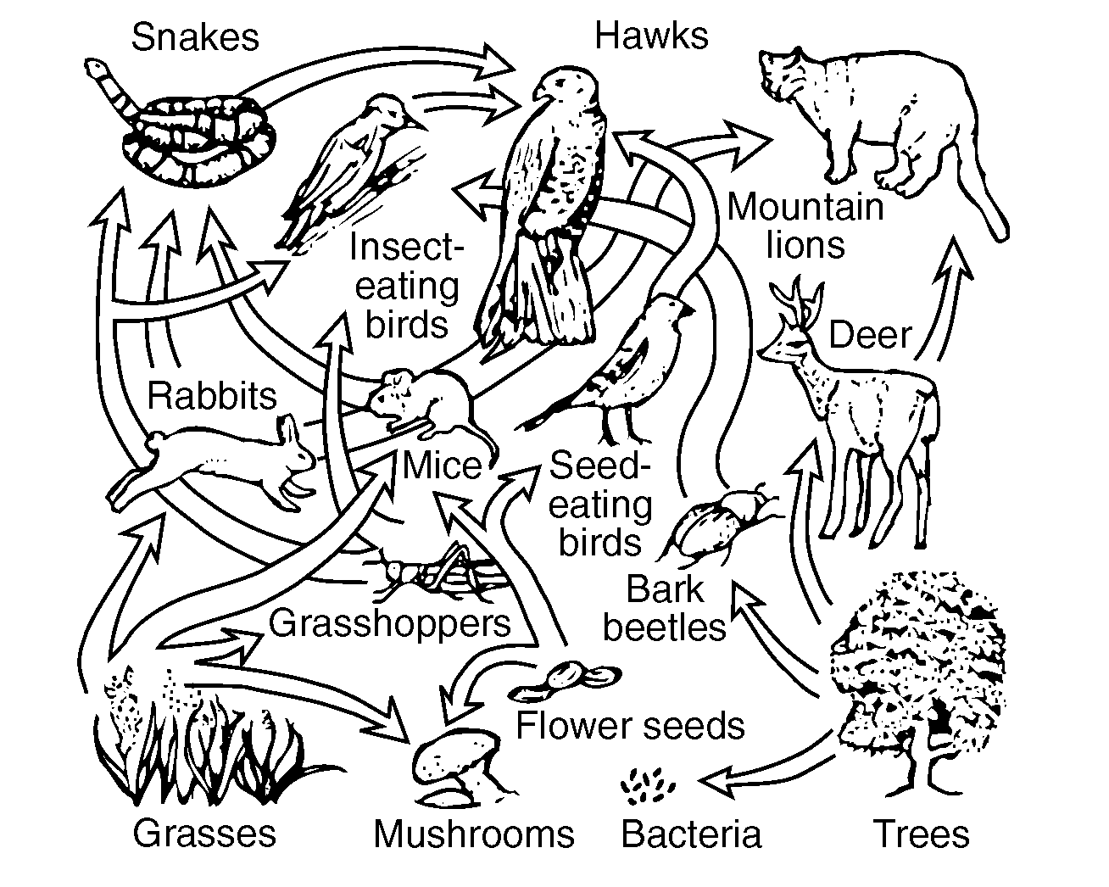
- Energy in an Ecosystem
  - Sunlight provides all energy for life on Earth.
  - Sun’s energy is stored in the chemical bonds of glucose through the process of photosynthesis.
  - Food chain – Shows 1 way that energy can “flow” through an ecosystem.

  - Food web – Shows many energy pathways.
  - Energy pyramid: Shows that energy gets lost with each step in a food chain
    - Energy is lost because every organism uses some of the energy for it’s own life processes. Only about 10% of energy is passed from one step to the next.
    - This is why populations of predators are typically less than the populations of their prey.
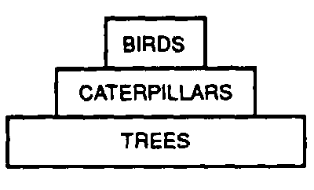

- Biodiversity refers to the variety of life on earth.
  - Diverse ecosystems (those with many types of species) are more stable than ones that are not diverse.
  - As habitats are lost and species become extinct, biodiversity is reduced. This is considered to be bad because:
    - Ecosystems with low diversity are less stable than ecosystems with more diversity,
    - Ecosystems with low diversity take longer to recover from environmental changes
    - Humans use organisms for many things such as food and medicine; by reducing biodiversity we are losing potentially valuable resources.

- Ecological Succession: this is a change in plant communities in an area over time

  - The organisms in each stage of succession change the environment, and allow new organisms to move in and replace them.
  - Climax Community: the final dominant plant community in a succession
    - The climax community is determined by the local climate.
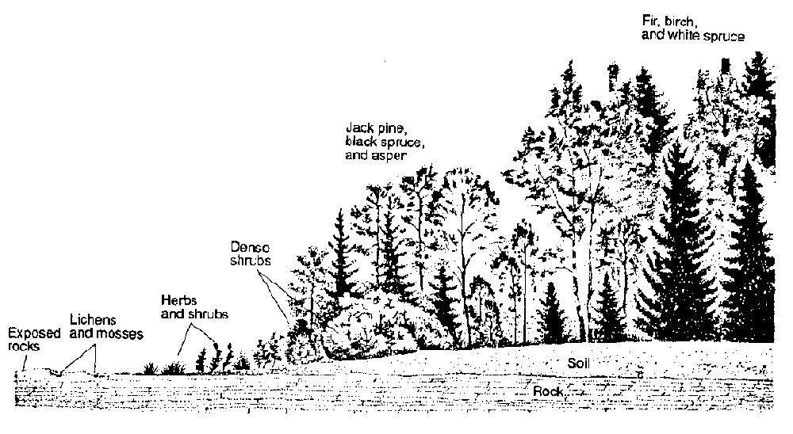
      - Ex: Kansas has very fertile soil, but not enough rain to support trees, so succession stops with grasses and shrubs.
  - Any temporary disruption of a community will begin the process of succession all over again.
      - Ex: If a forest fire kills all the trees in an area, succession will eventually return the area back into a forest, but it much first pass through all the necessary stages.

- Human Impact: Human actions can have both a negative or positive impact on the environment.
  - The primary reason humans have a negative impact on the environment is because the human population is growing, which places a greater demand on resources such as food, water and space.
  - There are no easy solutions to any ecological problem. Every solution can have negative consequences. Choosing the “right” actions requires weighing the benefits with the risks.
  - Human actions that generally have a negative impact on the environment include:
    - Development/industrialization
    - Pollution
    - Farming
    - Overhunting,/overgrazing
    - Clear cutting/deforestation
    - Introduction of foreign species
  - Actions being taken by humans to reduce or repair damage to the environment include:
    - Recycling wastes
    - Conserving available resources
    - Using cleaner resources (ex: solar over fossil fuels)
    - Protection of habitats and endangered species
    - Use of biological controls instead of pesticides and herbicides
    - Farming native plants (ex: cocoa in the rainforest)
    - Planting trees to replace those cut down.
    - Rotating crops or planting cover crops to reduce soil loss.
    - Passing laws to control pollution, land management, hunting, fishing, etc.

- Specific Environmental Problems:
  - Acid rain
    - Cause: high sulfur coal burning in Midwest
-- combines with water in clouds and falls as acid ppt
    - Negative effect: damages forests, kills aquatic life in lakes
    - What can be done: reduce coal burning, lime lakes
  - Depletion of ozone layer
    - Cause: CFC's from plastics and refrigerants
    - Negative effect: more skin cancer and cataracts
    - What can be done: use materials which are CFC free
  - Loss of habitat (ex: deforestation)
    - Cause: humans exploit environment for land and resources
    - Negative effect: loss of animal habitat
    - What can be done: recycle and reuse, replant trees
  - Loss of diversity
    - Cause: cutting down forests, poaching
    - Negative effect: destroy habitats, sources of drugs, foods, aesthetic beauty
    - What can be done: enforce laws, protect the rainforest, education

  - Global warming
    - Cause: CO2 from fossil fuels hold in earth heat
    - Negative effect: more insect borne disease, rising coastal sea levels, more violent storms, changed precipitation pattterns
What can be done: car pool, recycle, plant trees
  - Introduced species
    - Cause: humans carelessly bring in species from other areas
    - Negative effect: out compete native species, no natural enemies
    - What can be done: quarantine for pests
Example of a Controlled Experiment:
Hypothesis:
If people chew gum it will improve their memory.
Independent variable:
Chewing gum – some people will chew gum, some will not.

Dependent variable
Memory – all groups should have their memory checked both before and after the experiment to see if it was improved.

Experimental Group
Group that chews gum.

Control Group
Doesn’t chew gum (remember – the control group never receives the new treatment)

Constants
Should be the same for both groups:
People in each group should be of similar health with similar memory, with similar mixes of sexes, ages, and ethnicities. Each group should also be tested in the same way.

Data Collected
You should test people’s memories both before and after the experiment.

Topic Nine: Experiments and Labs
- Terms:
  - Observation: What is seen or measured.
  - Inference: A conclusion based on observation or evidence.
  - Hypothesis: A prediction based on available evidence. A good hypothesis states both cause and effect.
    - A correct hypothesis can be tested and falsified (proven incorrect) using an experiment.
    - The easiest way to write a correct hypothesis is as an “if-then” statement. (ex: If I give patients this pill, then they will not get sick.)
  - Theory: An explanation of natural events that is supported by strong evidence.
    - Theories tie together many scientific facts, hypotheses and laws.
    - Common Mistake: “Theories are things that are opinions, or are not proven.”
This is an incorrect use of the word “theory” in a scientific context. A scientific theory is not a simple guess or conjecture, and is strongly supported by evidence.

- Controlled Experiments: Compares the results of an experiment between one or more experimental groups with a “normal” group.
  - Experimental group: Group being tested or receiving treatment.
  - Control group: “Normal” group. Should be identical to experimental group in every way except one: it does not receive the new treatment.
  - Placebo: A sugar pill or other “fake” treatment given to the control group. Usually only needed when using human subjects.

  - Independent Variable: Variable that is being tested (ex: new drug, new fertilizer).
    - The “If” part of an “If-then” hypothesis.
    - The independent variable is always plotted on the X axis.
    - Dependent Variable: Variable that is measured at the end of an experiment; the results.
    - The “then” part of an “If-then” hypothesis.
    - The dependent variable is always plotted on the Y axis.

- Graphs and Data Tables
  - Data tables are used to organize data which will be plotted in a graph.
    - First column in the table is for the independent variable.
    - Second column is another for the dependent variable.
    - Each column should be titled, and include units of measurement.
    - Data in the table must be arranged in ascending or descending
order.

  - Both the x and y axis of the graph must be labeled or titled. These labels are typically the same ones used in the data table. Once again units of measurement must be written with the title.
    - The independent variable is always plotted on the x-axis.
    - The dependent variable is always plotted on the y-axis.

  - The x and y axis must be numbered.
    - These numbers must increase by a uniform increment (that is you must count by 1’s, 2’s, 5’s, 10’s, etc).
    - Your numerical scales should take up most of the axes. Squeezing it all into the bottom corner makes the graph impossible to read and no credit will be given.
    - The numbers must line up with the grid lines of the graph, not with spaces between them.
    - You do not need to start numbering your axis with 0.

  - To date, all graphs drawn on the LE Regents have been line graphs. Any student who draws a bar graph instead of a line graph will be denied credit for this part of the test.

  - All points plotted on your graph must be surrounded by a circle (or sometimes a square or triangle, depending on the directions).
- Characteristics of a good experiment:
  - Can be repeated the same way and get the same results.

  - Have large sample size/many test subjects.

  - Are performed over longer periods of time.

  - Test only one independent variable. All other characteristics of the tested groups should be the same.

  - Are peer reviewed – examined by other scientists to determine its accuracy.

  - Must test the hypothesis and show whether it is wrong or right.

  - Is objective – the experiment and conclusion are fair and unbiased. Fact and opinion are not mixed.

  - The experiment follows established ethical and legal standards.

Topic Ten: The State Labs (Part D)
- Making Connections (aka The Clothespin Lab)
  - Part A
    - What you did: measured how exercise affected pulse rate.
    - What you learned: exercise increases pulse rate
  - Part A2
    - What you did: Squeezed a clothespin for 1 minute, then squeezed it again for another minute
    - What you learned:
      - If you squeezed more the second round, it may have been because your finger muscles were “warmed up” from increased circulation.
      - If you squeezed less the second round, it may have been because your finger muscles were fatigued.
  - Part B
    - What you did: Designed an experiment to test how exercise affects squeezing a clothespin.
    - What you learned: How to design an experiment (see pages 3-5).

- Relationships and Biodiversity (Botana curus lab)
  - What you did: Compared 4 species of plants, based on structural (physical) and molecular (chemical and genetic) traits.
  - What you learned:
    - Species that are related share similar traits.
    - Different techniques (such as gel electrophoresis and paper chromatography) can be used to determine relationships between organisms.
    - Endangered species should be protected because they may offer benefits to humans.
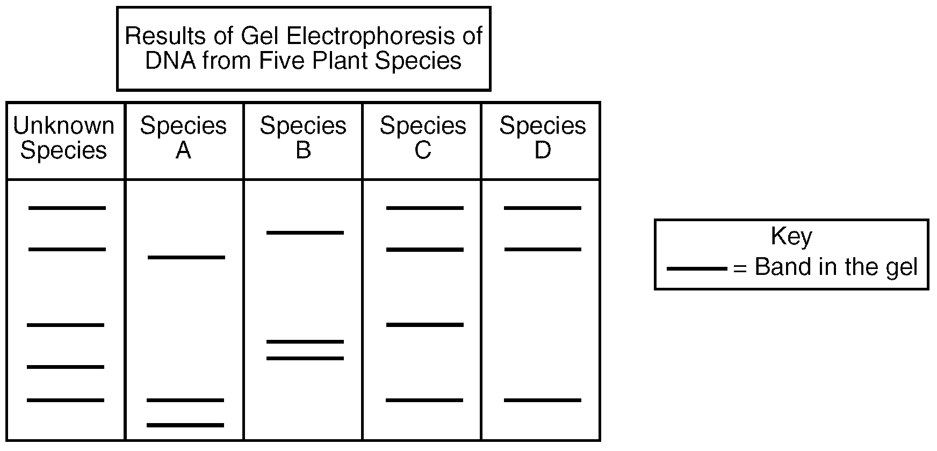
Gel Electrophoresis – A technique used to show how species are related to one another.
Restriction enzymes cut DNA into fragments, which are placed into a well in a gel plate.
An electric current carries the DNA fragments through the gel, separating them according to size (smaller pieces of DNA are carried farther from the well than larger pieces). This creates a pattern of bands which is unique for every organism.
Related organisms will show similar banding patterns because their DNA have similar base sequences.

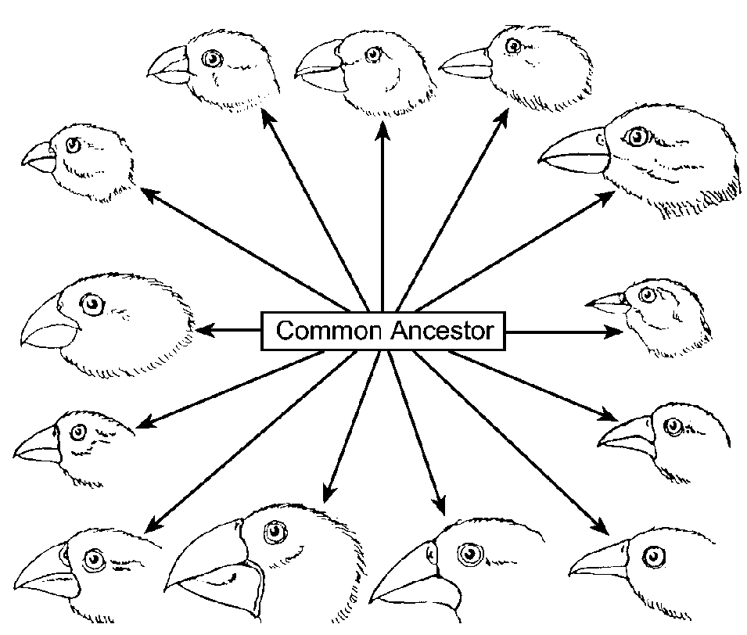
- Beaks of Finches
  - What you did: Played different finch species competing for food.
  - What you learned: Different environmental conditions (food) favored different species of finch, allowing some to survive and reproduce, but not others.

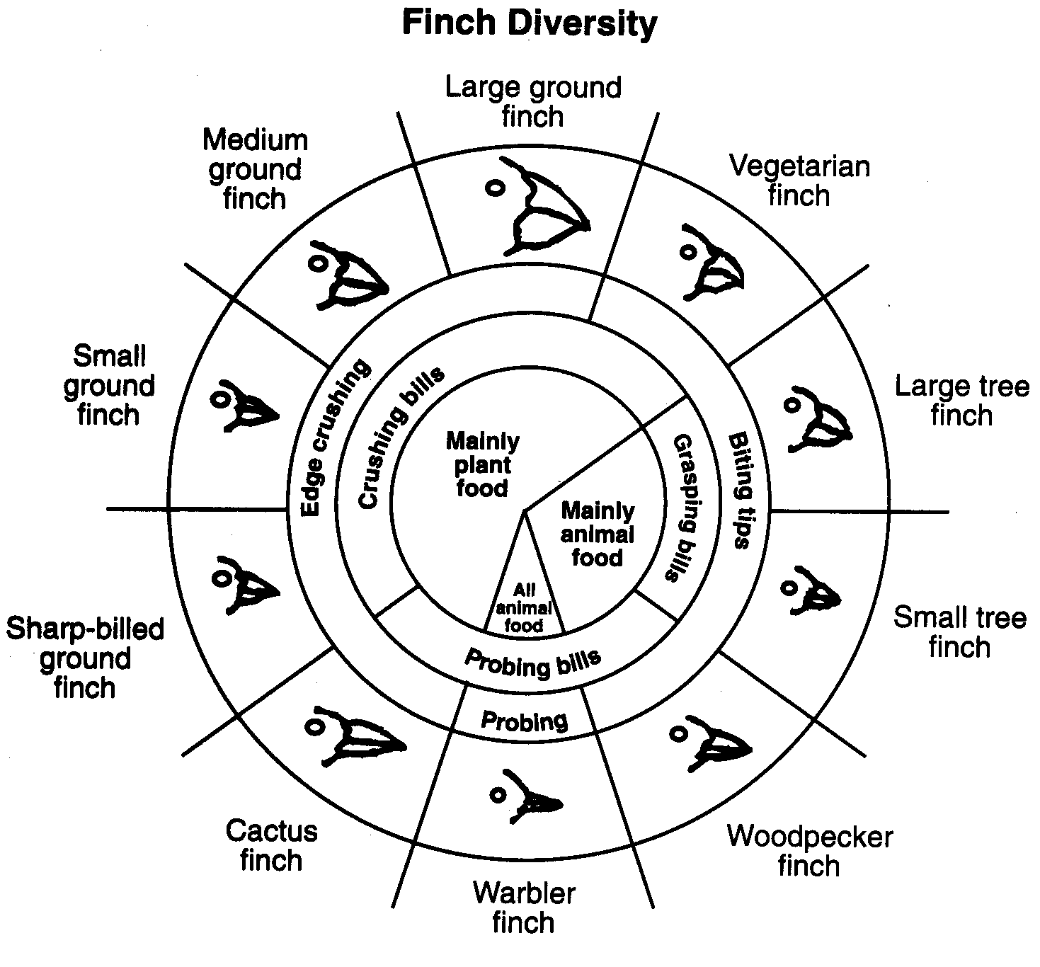

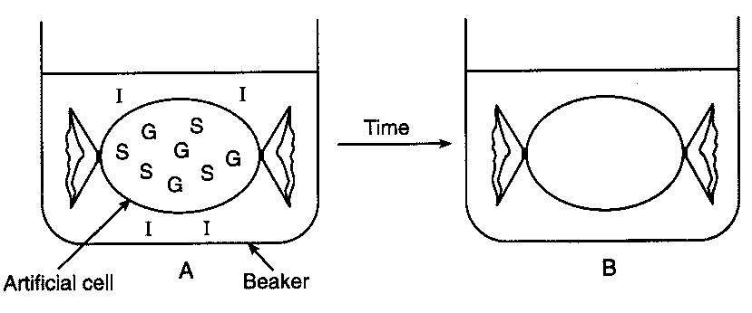
- Diffusion Through A Membrane
  - Part A
    - What you did:
      - Made a model cell using dialysis tubing.
      - Put glucose and starch inside your “cell.”
      - Put starch indicator (iodine) outside cell
    - What you saw:
      - Inside of cell turned black because iodine diffused into the cell
      - Because outside of the cell was not black, you know the starch did not diffuse through the membrane.
      - Used blue glucose indicator (Benedict’s solution) to see that glucose did diffuse through the membrane.
    - What you learned
      - Small molecules (glucose, iodine) can diffuse through a membrane on their own.
      - Large molecule (starch) cannot diffuse through a membrane on their own.
      - You can use indicators to identify the presence of specific substances.

  - Part B
    - What you did:
      - Looked at red onion cells under the microscope.
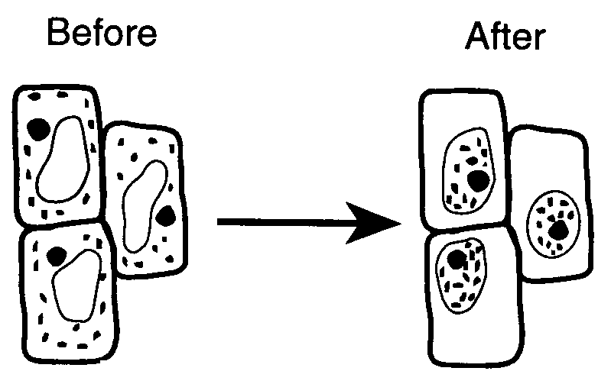
      - Added salt water to the onion cells.
      - Added distilled (pure) water to the onion cells.
    - What you saw:
      - Salt water caused the onion cells to shrivel.
      - Distilled water cause the cells to swell back to normal.
    - What you learned:
      - Salt water causes water to diffuse out of a cell.
      - In pure water, water will diffuse into a cell.

